**Data analysis Project Steps:**

1. Create a Problem Statement
2. Import and collect the data on which the analysis is to be done
3. Explore and Clean the data
4. Analyze the data to get useful insights
5. Present the data in terms of Reports/Dashboards using Visualization tools

Analysis is performed on the given dataset keeping the problem statement in mind .Problem statement also includes formulating the Research question and Hypothesis (Assumptions) .At the end we can check whether our Hypothesis is true or False .

**Business Problem :**

In recent years the City hotel and Resort Hotel have seen high cancellations rates . Each hotel is now dealing with a number of issues as a result , like depletion in Revenues and less than ideal hotel room use (leading to higher service charges) .Consequently , lowering the cancellation rates in both the Hotels is the primary goal to increase their efficiency in generating revenue and we need to assist them in dealing with this issue by solving the issue and also providing some business advice to help optimize the same .

**Assumptions:**

1. No unusual Occurrences (outliers) between 2015 and 2017 will have a substantial impact on the data used .
2. There are no unanticipated negatives to the hotel employing any advised technique.
3. The hotels are not currently using any of the suggested solutions .
4. Cancellations result in vacant rooms for the booked length of time.
5. Clients make hotel reservations in the same year they make cancellations

**Research Questions:**

1. What are the variables that affect hotel reservation cancellations ?
2. How can we make Hotel reservation cancellations better?
3. How will hotels be assisted in making pricing and promotional decisions ?

**Hypothesis :**

1. More cancellations occur when prices are higher
2. When there is a longer waiting list customers tend to cancel more frequently
3. The majority of clients are coming from offline travel agents to make their reservations .

**ANALYSIS AND FINDINGS**

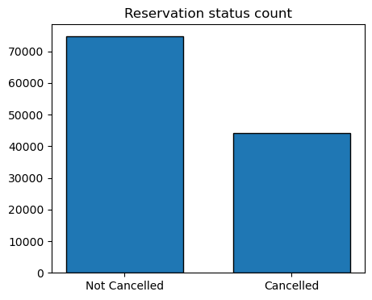

The Above bar graph shows the percentage of reservations that are cancelled and those that aren’t .Its still visible that there is a significant number of reservations that haven’t been cancelled .There are 37% of the clients who have cancelled their reservations which has a significant impact on the hotels’ earnings.

Moreover we find that in comparison to Resort hotels city Hotels resort have more reservations . Its possible that the Resort hotels are more expensive than those in the cities .

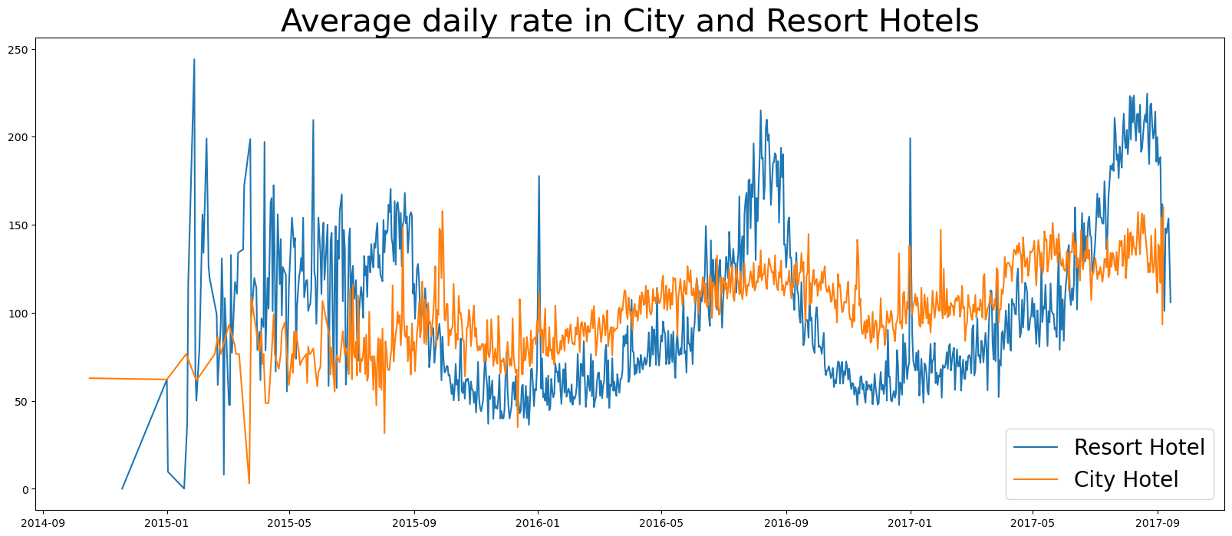

The above line graph shows that on certain days the average daily rate of a city hotel is less than that of the Resort hotels. Moreover the spikes in the graphs indicate that the weekends /holidays or end of the month may show a rise in the average daily rate.

Here we have plotted a clustered column chart to analyze the month wize Reservation levels .We have observed from the graph that the cancellations are highest in the month of Jan and lower in the months of August and Sept whereas the reservations are higher in the month of July and August and lower in months of Dec and Jan.

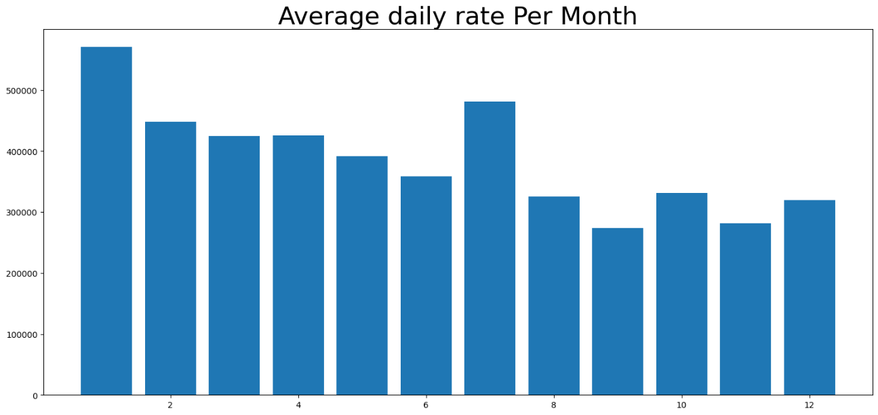

From the Above graph we finally conclude that cancellations are common when the process are high and vice versa ,thus the ADR/price is very critical factor for cancellations .

Next we figure out which country has the highest reservation cancelled . The topmost country is Portugal with highest number of cancellations.

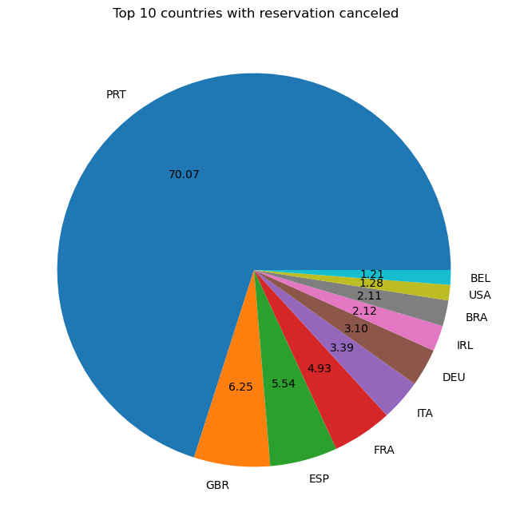

Next we check the area from where the guests are visiting the hotels and making the reservations amongst the 8 different market segments ('Direct' ,'Corporate' ,'Online TA', ,'Offline TA/TO', 'Complementary' ,'Groups' ,'Undefined', 'Aviation').We figure out that about 46% of the clients come from Online Travel agencies whereas 20% come from 'Offline TA/TO' and only 10 % clients book hotels by directly visiting them .Thus our Hypothesis was incorrect.

**Suggestions:**

1. Cancellation rates rise as the price does. In order to prevent cancellations of

reservations, hotels could work on their pricing strategies and try to lower the

rates for specific hotels based on locations. They can also provide some

discounts to the consumers.

2. In the month of January, hotels can start campaigns or marketing with a

reasonable amount to increase their revenue as the cancellation is the highest in

this month

3. They can also increase the quality of their hotels and their services mainly in

Portugal to reduce the cancellation rate.